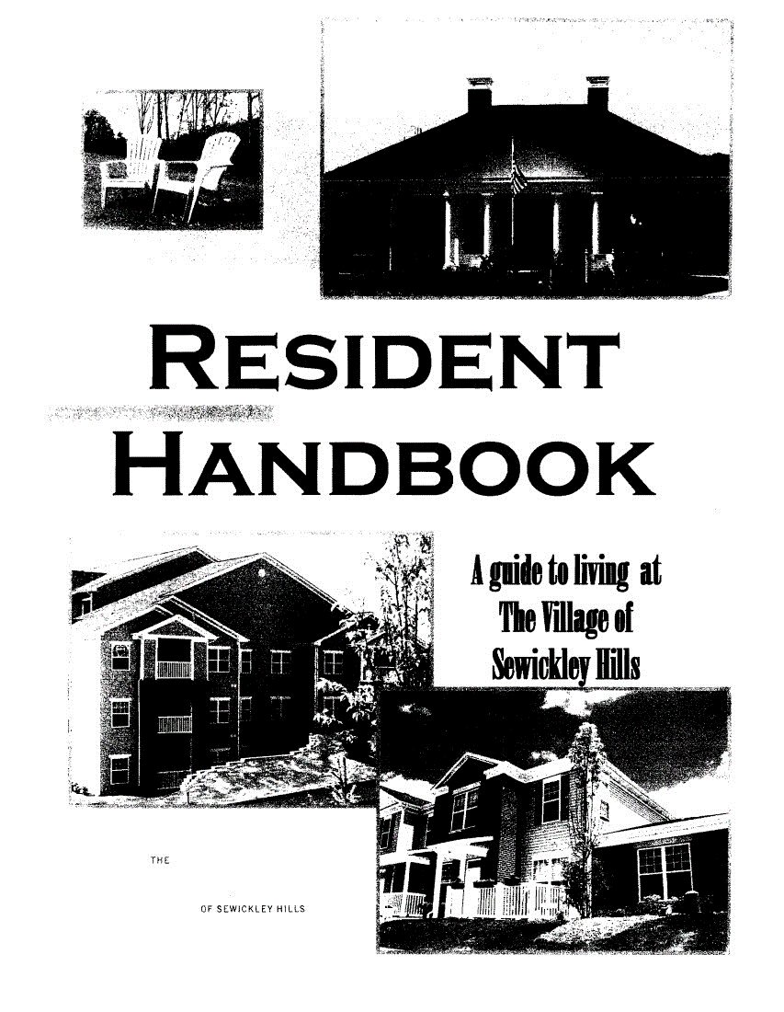

WELCOME TO THE VILLAGE OF SEWICKLEY HILLS

The VOSH does not retain copies of keys to your home or garage. Keep one in a
safe place and make copies as needed.

Entrance gate keys may be purchases and/or replaced for a fee of $25.00. Fobs are available for $50.00. Please contact CMP.

Homeowners are encouraged to register with the VOSH website to receive announcements and updates pertaining to the community.

The clubhouse may be rented for a fee of $45.00. Visit the website for details on how to reserve.

CARD ACCESS SYSTEM INSTRUCTIONS

Homeowners over the age of 18 should receive two (2) access cards at the time the home is
purchased. In addition to the access cards, each unit will be assigned a 4-digit pin number. This
pin number is for resident use only.

RESIDENT ACCESS THROUGH THE FRONT GATE

Residents may access the front gate one of three ways:

- Contact with the access card and the proximity reader located at the kiosk.
Once the card has communicated with the reader, the gate will open.
- Enter the 4-digit pin number by pressing the "STAR" key (*) and then the pin.
- Press the button on the FOB. If a resident is interested in purchasing a FOB for $50.00, contact CMP.

The gate is programmed to close immediately after the vehicle passes through. Do not tailgate if
following another vehicle through the gate without stopping at the kiosk, as the gate will close
and may cause damage.

RESIDENT ACCESS TO CLUBHOUSE

Residents will be required to use the access card to gain entry to the clubhouse, tanning bed and
fitness center. In addition, a 4-digit code will be required to enter the main area of the
clubhouse and the fitness center. Please contact the Board or CMP for these codes.

GUEST ACCESS THROUGH THE FRONT GATE

Guests may gain entry to the property by entering a random 3-digit extension number that is
assigned to each unit. To protect resident privacy, this number does not correspond with any
townhome/condo house number or phone number. Guests may access this extension number by
scrolling through the directory at the kiosk and locating the resident's last name. When guests
dial the number, a call will be placed to the phone number provided by the resident (cell number
or home number).

Guests may also enter the extension number directly, by-passing the directory, by pressing the
"POUND KEY" (#) followed by the 3-digit extension number.

To open the gate, resident will answer the call and press the number "6".

Posting the 4-digit access pin on the kiosk is not permitted and may result in the pin being
immediately deleted from the system.

SECTION I

AREA CONTACTS
AND
EMERGENCY NUMBERS

Please contact 911 for all emergencies

Fire…………………………..412.364.1700
Police……………………….412.364.8300
Ambulance……………….412.766.5600

AREA HOSPITALS

North Hills UPMC Passavant………….412.367.6700
Sewickley Valley Hospital………………412.741.6600
Ohio Valley Hospital……………………..412.777.6161
Suburban General Hospital……………412.734.1800
Allegheny General Hospital…………..412.359.3131

UTILITIES and OTHER PROVIDERS

Utility Providers:
Electric
Duquesne Light……………………..412-393-7000

Gas
Equitable Gas…………………………800-654-6335

***Please Note: The above utilities need to be transferred into your name within 72 hours
of closing to avoid any disruptions in service.

Water and Sewage

Cable TV / High Speed Internet / Phone Service
Comcast……………………………………800-COMCAST

Additional Numbers
Guardian Protection Services…….1-800-905-5270

Local OH Township Taxes……………412-364-4549

Avonworth School District…………..412-369-8738

SECTION II

INTERIOR HOME

OPERATIONG INSTRUCTIONS FOR GAS FIREPLACES

MANUAL CONTROL LIGHTING INSTRUCTIONS

1. STOP! Read the safety information.
2. Make sure the manual shutoff valve is fully open.
3. This heater is equipped with an ignition device (piezo) which automatically lights the pilot.
4. Refer to Figure 36. page 16 for the location of the piezo Ignitor and control knob. Push in gas
control knob slightly and tum control knob clockwise to the OFF position.
NOTE: Knob cannot be turned to OFF unless knob is pushed in slightly. Do not force.
5. Wait 5 minutes to clear out any gas. Then smell for gas, including near the floor. If you smell gas
STOP! Follow the instructions under "WHAT TO DO IF YOU SMELL GAS". page 26. If you do not smell
gas, go to the next step.
6. From OFF position. push in gas control knob slightly and rum counterclockwise ~ to the IGN
position. See Figure 37. Push in and hold control knob for 5 seconds.
NOTE: If you are running the heater fo the first time, it will be necessary to press in the control
knob for 30 seconds to allow air to bleed out of the gas piping.
7. With the control knob pushed in, push and release the piezo ignitor button to light the ODS pilot.
The pilot located on the right side of the heater, behind the front log and in front of the main
burner. If the piezo ignition does not light the pilot, refer to "MATCH LIGHTING INSTRUCTIONS"',
page 30.
8. Hold the control knob in for an additional 10 seconds to prevent the ODS pilot from shutting off
the gas white the thermocouple is warming up.
9. Release the control knob.
• If the knob does not pop out when released, stop and immediately call your service technician
or gas supplier.
• If the ODS pilot will not stay lit after several tries, push and tum the gas control knob clockwise
to OFF and wait IS seconds. Repeat steps 6 through 9.
10. Push in control knob and tum to desired setting (LOW or HIGH). The control knob must be set at
either the low or high position, and the control knob will pop out when positioned correctly. Do
not set the control knob at a position between LOW and HIGH. Refer to Figure 39 and 39.

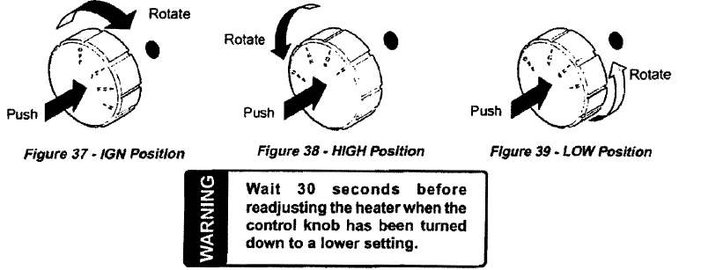

TO TURN OFF GAS TO HEATER
Tum control knob clockwise to OFF position to completely shut off the heater.

PAINT TIPS/INFORMATION

When touching up walls it is best to dab the area with the brush rather than dragging the brush up
and down or side to side. This will ensure as good a match as possible. Also try touch up paint
in an inconspicuous area first. Please note that bathroom and kitchen walls are eggshell finish and the other areas of the home are flat finish.

The paint color codes for the paint in your home are as listed:
SW 1038 Architectural Gray-Flat-Walls
SW Pure White Semi-Gloss-Trim
Please contact Sherwin Williams to order you paint

AIR HANDLER AND FILTER CHANGES

Your heat is provided by hot water from the water heater. This provides a warm moist heat that
is very efficient. We recommend that you change your filter a minimum of 4 times a year and
have your Air Conditioning condensing unit checked by a professional annually.

Filter sizes are as listed:
16x20 for 2 and 3-bedroom townhomes and 3-bedroom condominiums
14x18 for 2-bedroom condominiums

Tips for your heating system in your home:
• Keep the cold air return in the living room and stairwell free from any obstructions to
allow for air to flow properly.
• Keep doors open or cracked to promote the air flow into this area.
• Consider keeping the fan in the "ON' position to help promote air flow.
• When the fireplace is in use, keep the fan in the "ON' position.
• Keep objects that generate heat, such as lamps and candles, away from the thermostat.

SHUTOFFS

Townhomes
The main water shut-off valve is located in the laundry room above the water meter. This valve
controls the exterior hose bib located by the front door. The gas shut-off is located above the
laundry door.

Condominiums
The main shut-offs for both water and gas is located in the storage closet off of the patio.

All shut-off valves should work freely. Please refer to the drawings on the following pages to
direct you to the locations for the valves.

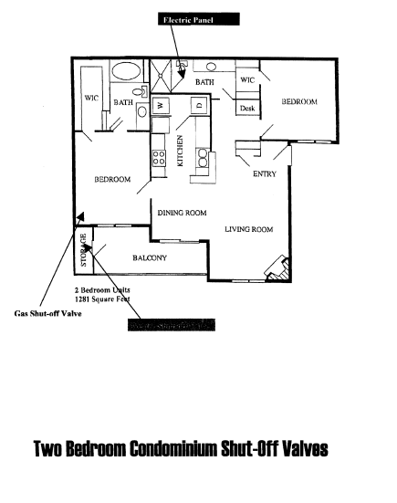

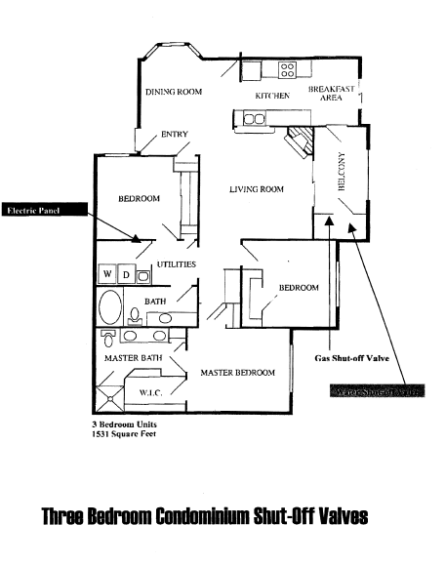

Interior Lighting

One of the switches in the living room and both bedroom switches operate one of the top plugs in
the wall outlets. 60-watt light bulbs are recommended for ceiling fixtures and bathroom fixtures.
The kitchen uses a 4-foot fluorescent tube bulb (for units that still have the fluorescent light fixture).

Thermostat Battery Replacement

The (original) thermostat in your home uses 2-AA batteries. If the room temperature is not displayed, the
batteries need to be replaced.

Breakers

If there is a loss of power to an outlet or lighting fixture, check to see if it is widespread. If only
one area is affected, check the breaker box located in the home. Make sure all breakers are
flipped to the "ON" position. If the breaker is in the "ON' position and there is no power, move
to the "OFF" position, then flip breaker back to the "ON' position.

For kitchen and bathroom outlets, check the GFI. This may need to be reset rather than the
breakers.

COMMON INTERIOR AMENITIES

Clubhouse
Residents can reserve the Clubhouse by contacting the management office. The Clubhouse features a warm and inviting atmosphere for any occasion that you may need to schedule. With the rental of the clubhouse all areas are available for use except the fitness center, tanning bed and pool areas at these areas are open to the resident 24 hours a day, 7 days a week and may not be reserved.
There is a full-service kitchen including a refrigerator, microwave and garbage disposal.

The Fitness Facility
This facility is open 24 hours a day to serve you best. We feature a fitness center with 2 treadmills, elliptical machine, free weights and weight lifting cross trainer. Residents can feel free to enter this
facility, through the side doors of the clubhouse using their resident cards after hours. We also offer a tanning facility to our residents 18 years and older.

Cinema Room
This home theater room offers a 72" Sony Television with high definition cable and surround sound. This room is perfect for watching your favorite sports or a movie that we provide for you to use.

Section III

EXTERIOR HOME

GARAGE KEYPAD ACCESS SYSTEM INSTRUCTIONS

All garages (whether attached or detached) are equipped with both a remote control that can be
used within an automobile, and a programmable keypad that can be used open and close the
garage door.

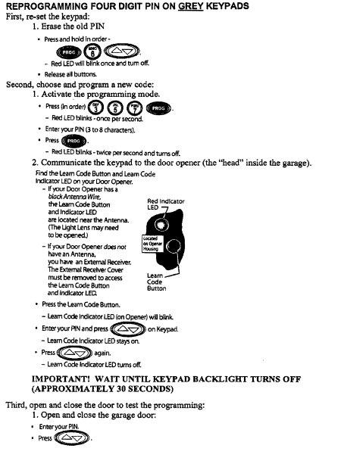
Battery Replacement
There may be a time when garage doors do not open or close due to power outages and battery
replacements. It is important to check the batteries in the remote and the wall keypad, first. The
wall keypad uses a 9V battery. The car remote uses an A23 battery.

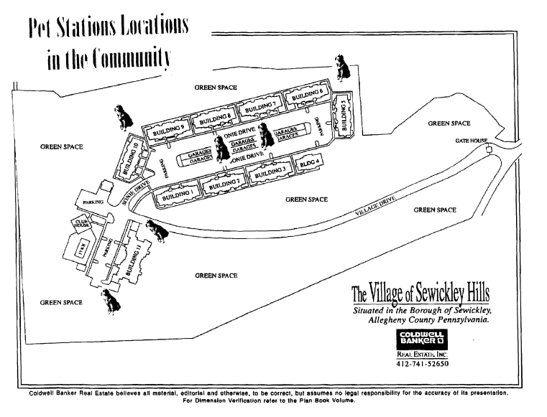

Doggie Stations
The installation of pet stations will be completed throughout the community in common areas for
home owners who have pets. We will provide doggie bags so you may pick up after your pet.
Please see the map that reflects where the stations will be placed. It is important again
that we are responsible for our pets' droppings so that we continue to keep our property beautiful.

Trash Compactor
The compactor is located across the drive from the clubhouse and is in a wooden containment.
Please make sure that all boxes are broken down before throwing them into the trash compactor.
All trash is to be placed inside of the compactor through use of the compactor door. If there is
no room to throw your trash in the compactor please compact the trash already in the container.
To compact the trash, push the key that is already in the machine located to the right of the door and release. Please make sure that the door is closed to the compactor before starting the compactor. You will hear the compacting start automatically. After compacting has finished you can now throw your garbage into the compactor and leave. **Please note that all trash must be disposed of properly to keep
our community beautiful and free of rodents that may cause disease. There is a $100.00 fee for garbage left on porches and outside of the compactor.

AWNINGS
The Association is allowing awnings to be installed over the three-bedroom townhome patios. If
awnings are to be installed they MUST meet all the requirements listed below and may only be
purchased through Mt. Lebanon Awning and Tent Company. Please make sure the awnings are:

1. Canvas construction
2. Black (# 4608) with white trim
3. Fully Retractable with no frame work
4. The maximum size when the awning is opened is 108x10

Questions can be directed to Mt. Lebanon Awning at 412.221.2233, the Board, or CMP.

Storm Doors
The Home Association is allowing the addition of storm doors to the front doors throughout the
community if desired by the resident. The doors must meet the following criteria in order to be
installed:

- Aluminum or vinyl construction
- White exterior only
- Full view glass (with retractable screen if preferred)

Please see the below photo provided for acceptable door choices or visit www.pella.com (see
model 3800). Please note the door does not need to be Pella, but must meet the criteria. Home Depot and Lowes are another option.

FEATURES
- 1-5/8" heavy-duty frame with reinforced comers.
- Overlapping frame for a clean look.
- Brass exterior handle with keylock; interior handle that matches door.
- Integrated Keyed Deadbolt
- Concealed Installation Screws
- Heavy-Duty Hinges
- Interior Handle Matches Door Color
- Sweep Matches Handle Finish

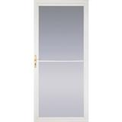

Restrictions on Grilling

Townhomes
Grilling for the three-bedroom townhomes is permitted as long as the gas grill is pulled away
from the structure of the building. *Please note if awnings are installed grilling is not permitted
under the awnings when they are rolled down as a fire hazard has been created.

Grilling for two-bedroom townhomes is permitted as long as the grill is pulled out from under the patio overhang. Grilling under the roof can cause a severe fire hazard.

Condominiums
Grilling is NOT permitted on the patios or balconies of the condominium building at any time. Please note
that some condominium homes do have attached garages in which grilling can be permitted in
the driveways of these homes as long as the grill is away from the building structure. Patios that
are open to common areas can have the option to pull the grill away from the building structure
and into the common areas so they may also grill.

***Please note that grills cannot be stored on balconies with the propane gas attached as this is a fire hazard.

***Anyone using a grill in Allegheny County can be fined $1000.00 for using a grill on a patio or balcony and creating a fire hazard within the community. This is not enforced by the management but the local township office and fire marshal. Information regarding grilling can be obtained through the Ohio Township Office website.

*Please be advised that the safest alternatives to gas grills are the electric grills you can now purchase to give you the same effect and even reduce health problems.

*A grill will be provided for you to use in the pool area if you cannot grill in your home area. Please be sure to clean the grill after each use.

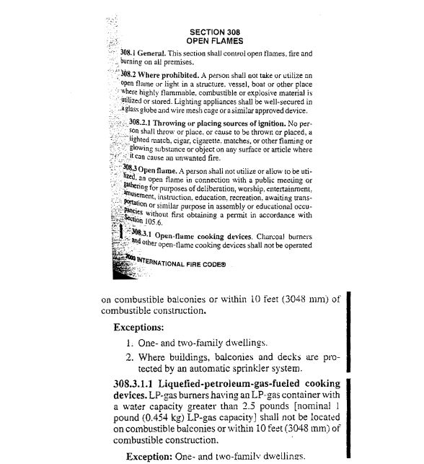

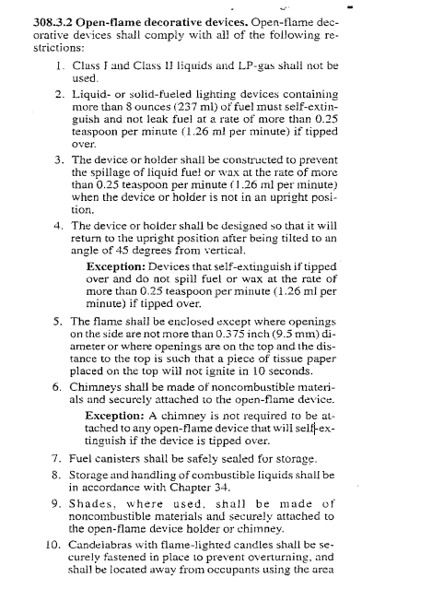

COMMON EXTERIOR AMMENITIES

Common Grounds
All areas outside of your patio or balcony or considered common areas or green space. All residents for purposes set forth in the Condominium documents can use these areas. Also, in the common area there are pet stations for those of you that have furry friends so we can pick up after our pets in a convenient way and keep the community beautiful.

The Pool House and Facility
The pool is open from 7am-10pm. It is 3 ft -5 ft, heated with changing rooms and bathrooms.
Each year the pool will open in the late spring and remain open until the late fall. Although this facility cannot have private parties it always seems to create a great summer afternoon where neighbors can socialize. Guests are permitted with 4 guests per unit.

The Clubhouse and Amenities
The workout facilities and the tanning bed are available 24-hours / 7 days a week with the use of a keycard.
The amenities are for resident use only.

The Gate House
The Village has an entry gate system that is closed 24-hours / 7 days a week.
The community hosts a gate system to which there are pass codes for residents. The system is also operated at the clubhouse for gaining access to the fitness facility.

Fire Extinguishers Reminder
It is the responsibility of the residents to have their extinguishers checked yearly so that they are
working properly in your household. If you have any questions, please contact CMP.

Condominium Breezeways
The condominium breezeways are considered common areas throughout the community. For
fire safety reasons we advise that all residents living in the condominiums please limit the
outside area of their front door to include one decoration and 1 door mat. Please do not place
furniture or other such belongings in this area.

Dryer Vent Maintenance
It is important that homeowners maintain their dryer vents that go from the dryer to the outside
of the home. You can limit the amount of lint that passes from your dryer to your vent by
constantly emptying the dryer lint trap. In addition, it is important to make sure you are
periodically removing the hose from the dryer and cleaning this out. Please note that if dryer
vents are not kept free and clear they can create a dangerous fire hazard.

Planting flowers
The planting of flowers is allowed in the areas around your front door and patios in the mulched
areas only. Please make sure that when planting flowers you are only choosing from the annual
flowers. The Management also asks that no vegetables be grown in these areas either. If
you have questions regarding planting flowers, please contact the Board or CMP.

Maintenance Tips
- Satellite Dishes cannot be affixed or attached to the building and its structures at all. All
satellite dishes must remain in the patio area. Before purchasing a dish make sure your
unit has a southern exposure that is needed for reception.
- We recommend that you shut off the washer valve after each load of laundry.
- No Bird Feeders please as they attract rodents and disease around your home area.
- Please do not put ladders inside of tubs as this can cause cracking.
- Please be careful when hanging pictures and putting nails and screws into the wall as
there may be an electrical wire, sewer line or water line behind the wall itself.
- EXTERIOR FAUCET - In your home there is a blue valve located in the laundry room ceiling. This valve
controls the water to the outside faucet. Please turn the valve to the off position and then
go to the outside faucet and turn this on to drain any water from the lines. This will
prevent any freezing of the lines throughout your home in the winter.
- BREAKER BOX LOCATION - The breaker box is located in the upstairs bedroom behind the entrance door to the room. All breakers are labeled accordingly.

**If you have any questions regarding the above mentioned items please do not hesitate to contact the Board.

Emergency Maintenance Examples:
1. Fire Alarms
2. Fire Sprinkler System is going off
3. Gate Problems
4. Storm Damage to Exterior of Buildings

Section IV

In and Around the Community

DISCLOSURE FOR MAINTENANCE

Maintenance Responsibilities
Units shall be maintained and repaired by each Unit Owner and the Common Elements shall be
maintained and repaired by the Association. All maintenance, repair and replacement by Unit
Owners shall be in a manner that will not impair the structural integrity or appearance of the
buildings or impair any mechanical, plumbing or electrical system therein. The materials and
workmanship used in such maintenance, repair or replacement by Unit Owners shall be of the
same type and quality as were originally provided in the Unit.

Each Unit Owner shall be required to repair or replace any portion of his or her "Unit that, if not
repaired or replaced, would adversely affect the exterior appearance of the Property or in any
manner materially adversely affect another Unit. If any Unit Owner fails to comply with the
requirements of the preceding sentence, the Association may with prior notice to Owner and
reasonable opportunity to cure, in its sole discretion make such repair or replacement and assess
the expenses thereof against such Unit Owner. Any Material Improvement must be carried out
pursuant to plans and specifications prepared by an architect or engineer licensed in
Pennsylvania and submitted to the Association for prior approval, said approval not to be
unreasonably withheld. Further, as to any Material Improvement:

- The Unit Owner shall at his or her own expense obtain all permits and
licenses, including a building permit, if necessary, for any work and
shall provide the Association with copied thereof. All contracts for
which a mechanics lien might be filed shall include a "no lien"
agreement, and proof of filing same prior to construction start shall be
provided to Association.

- All costs related to any Material Improvement or the approval thereof
by the Association, including without limitation the reasonable cost of
the Association's architect's review. Shall be paid by Unit Owner.
The Executive Board may require the posting of a deposit or other
financial security to cover such costs as it, in its sole reasonable
discretion, deems necessary.

Association Maintenance is responsible for the upkeep of the property exterior and all common
areas. This is to include the lighting of the garages street light, gutter, downspouts, roof repairs,
landscaping, snow removal and trash removal of the property. We also will take care of any
cleaning that needs to be done in the breezeways and railings of the Condominium buildings.

**Anything on the interior of the home is the responsibility of the Home Owner.

Snow Removal and Landscaping
The snow removal of the property starts at 6AM and performed by a contracted company hired by the Board. Please note that along with snow removal is the purchase and disbursal of salt
around the community and on roadways.

Landscaping of the property is performed by a contracted company hired by the Board.

Amenity Maintenance
Association Maintenance will also be performed for all the common amenities throughout the
community including any maintenance and cleanup of the clubhouse facility, fitness facility,
tanning facility, conference room, resident center and movie room. We will maintain
maintenance on all the equipment located in any of these areas.

Emergency Maintenance
What is emergency maintenance? Emergency Maintenance is anything that can cause damage to
the building as a whole that is uncontrollable. The two most serious emergency maintenance
requests are fire and flood. *Please note that any fire or flood needs to be reported to the 911
dispatcher first and then the property emergency line. Do not call the maintenance line
first as you need to have emergency personnel dispatched for the above mentioned
emergencies. All other maintenance issues are the responsibility of the residents if the issue is
in the interior of the home. If the maintenance is an exterior issue that is not detrimental to the
building as a whole, please wait to inform CMP and/or the Board on normal business days. We will not
respond to non-emergency maintenance issues.

WHAT TO DO IN THE AREA?

AREA RECREATION
Sewickley Valley YMCA...............................412-741-YMCA
Sewickley Community Center.....................412-741-5430

LOCAL PARKS
Avonworth Community Park...................... 412-364-0064
Ohio Township Park……………………………….. 412-364-6321

PRIVATE CLUBS
Diamond Run Golf Club ...............................412-741-3002
Woodland Swim Club………………………………..412-741-7500
Highland Country Club………………………………412-761-6000
Edgewood Country Club……………………………412-741-8500

ARTS AND THEATRE
Sweetwater Art Center……………………………….412-741-4405
Performing Arts for Children…………………….. 412-741-4120

FOOD AND RESTAURANTS
Andora Restaurant……………………………………..412-749-5245
Mt. Nebo Deli and Catering………………………..412-741-6078
Pizza Roma…………………………………………………412-741-1599
Vocelli Pizza……………………………………………….412-741-7800
Sesame Inn………………………………………………..412-366-1838
China Palace………………………………………………412-741-7423

